Farm Management SYstem (FMS)

PHASE 1: BRAINSTORMING & IDEATION

Project Overview & Objective :

¤ The Farm Management System (FMS) is a simple Salesforce cloud app built to digitize daily farming operations.
¤ It helps track farms, crops, farmers, and buyer details in one single place instead of using paper books or spreadsheets.

Key Goals:
- Change paper record-keeping into digital format.
- Reduce simple human mistakes during data entry.
- Keep all farm, crop, and buyer info organized safely.
- Show live sales and harvest progress using simple dashboards.

Problem Statements :

User | What they want to do | Problem faced | Reason | How they feel
Farmer | Keep track of daily crop logs | Info gets lost or miswritten | Writing everything manually in notebooks | Frustrated
Farm Manager | Check monthly harvest & sales | Reports are slow and full of errors | Data is scattered across multiple Excel sheets | Stressed
Buyer | View available crops and prices | Doesn't get updated stock info | No shared system to see current stock | Annoyed
Admin | Control who sees what data | Risk of unauthorized edits | Managing permissions manually | Concerned

Empathy Map :

- Target Users: Farmers, Farm Managers, Buyers, System Admins.
- Think & Feel: "I need an easy way to store my harvest records without losing them."
- See: Old paper registers, misplaced receipts, and messy spreadsheets.
- Hear: Buyer complaints about delayed stock updates.
- Say & Do: Spends hours every week writing down crop details by hand.
- Pain Points: Record damage, calculation mistakes, and lack of security.
- Gains: Quick search, automatic totals, safe cloud storage.

Idea Selection :
We compared 3 options:
- Paper Books: Very easy to lose or damage.
- Excel Sheets: Easy to corrupt formulas by accident.
- Salesforce App: Built-in security, easy object creation, and ready-made dashboards.
Selected Solution: Salesforce Cloud App because it is easy to set up without writing huge code.

PHASE 2: REQUIREMENT ANALYSIS

User Story :

In the Farm Management System (FMS), as a farmer, farm manager, or system administrator, I want to use a centralized Salesforce-based platform to record and manage farm, crop, farmer, and buyer information so that all agricultural data is stored securely and systematically. I want to enter and update farm details, crop production records, and buyer transactions easily through a user-friendly interface with proper validation rules to prevent incorrect entries. I also want the system to generate real-time reports and interactive dashboards so that I can analyze farm productivity, monitor sales, and make informed decisions. Additionally, I want role-based access and secure data storage to ensure that sensitive information is protected while enabling smooth collaboration among users. This system will help reduce manual paperwork, minimize errors, improve efficiency, and support data-driven farm management.

Main Workflow :
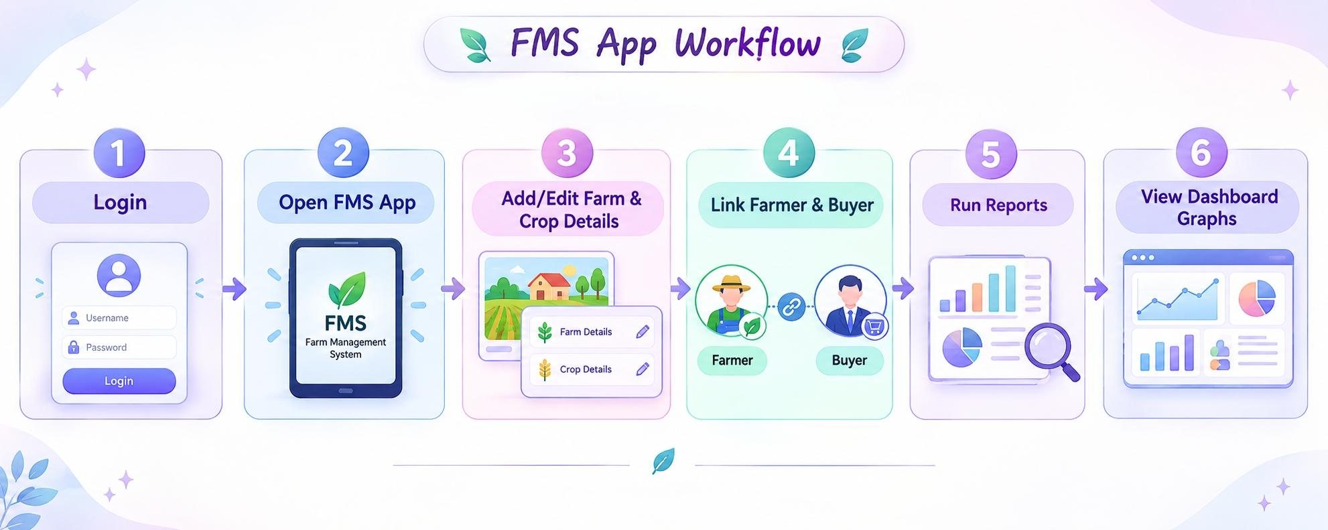

Requirements :

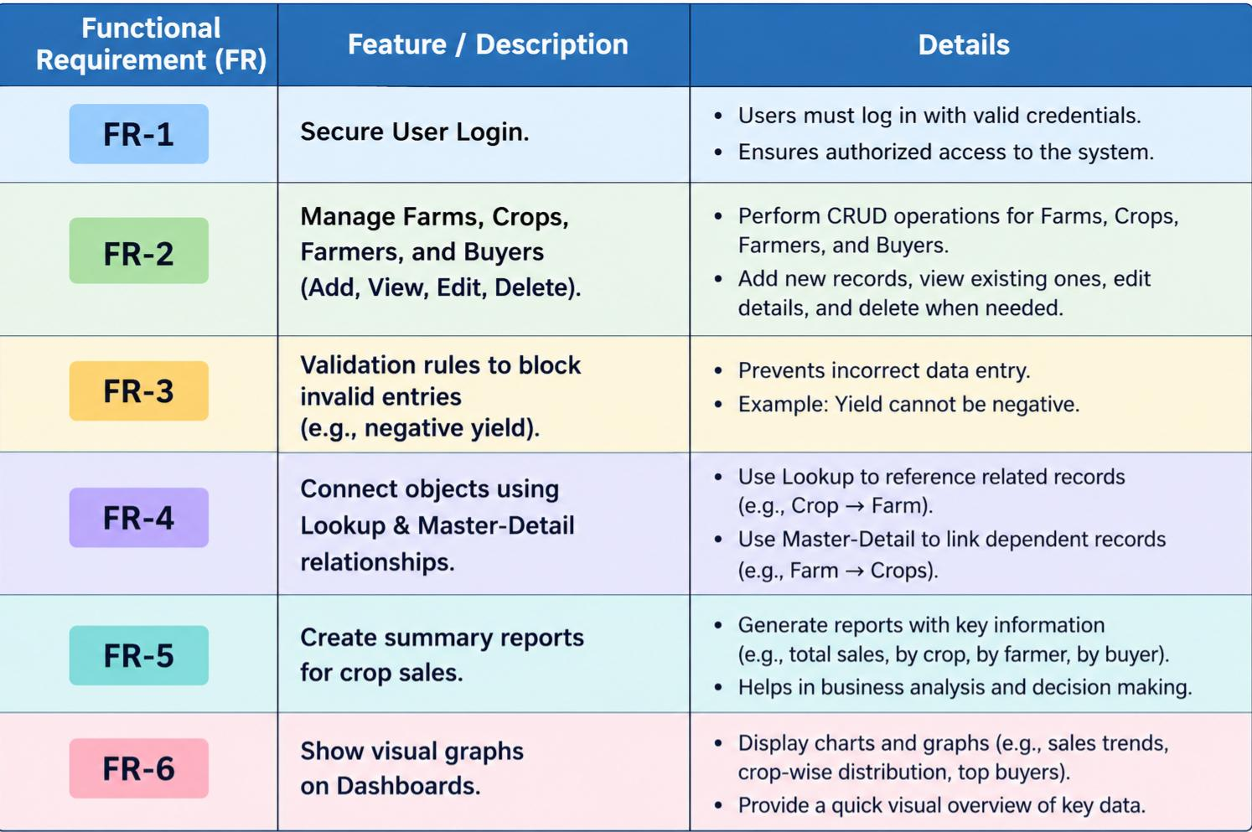
Functional Requirements (FR)

Non-Functional Requirements (NFR)
- Simple UI: Easy Lightning interface for non-tech users.
- Speed: Reports load in under 3 seconds.
- Security: Role-based access so farmers only see their data.

Tech Stack Used :

- Frontend: Salesforce Lightning App
- Database & Logic: Custom Objects, Validation Rules
- Analytics: Salesforce Reports & Dashboards

PHASE 3: PROJECT DESIGN

1. System Architecture Layers :
The Farm Management System is designed using a 4-layer cloud architecture on Salesforce:
- Presentation Layer: Salesforce Lightning UI & Custom App Interface (Tabs & Views).
- Logic Layer: Validation Rules and Field Dependencies to prevent wrong entries.
- Data Layer: Custom Objects, Custom Fields, and Object Relationships.
- Analytics Layer: Reports and Visual Dashboards for data tracking.

2. Data Model (Custom Objects & Fields) :

Objects & Field Specifications:

- Farm Object (Farm__c):
  - Farm_Name__c (Text) – Unique name of the farm.
  - Location__c (Text) – Address / Region of the farm.
  - Area_Acres__c (Number) – Total land area in acres.

- Crop Object (Crop__c):
  - Crop_Name__c (Text) – Type of crop planted (e.g., Rice, Wheat).
  - Planting_Date__c (Date) – Date of sowing.
  - Harvest_Date__c (Date) – Date of harvest.
  - Expected_Yield_Kg__c (Number) – Estimated harvest weight in kilograms.

- Farmer Object (Farmer__c):
  - Farmer_Name__c (Text) – Name of the worker.
  - Phone__c (Phone) – Contact details.
  - Assigned_Farm__c (Lookup to Farm__c) – Farm where the farmer works.

- Buyer Transaction Object (Buyer_Transaction__c):
  - Buyer_Name__c (Text) – Purchaser name.
  - Crop__c (Lookup to Crop__c) – Crop purchased.
  - Total_Amount__c (Currency) – Bill value.
  - Payment_Status__c (Picklist: Paid, Pending, Failed).

3. Object Relationship Mapping :
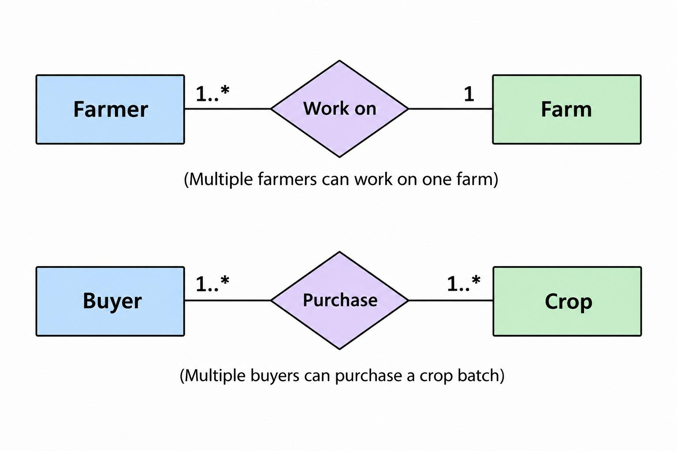

4.Security Setup :
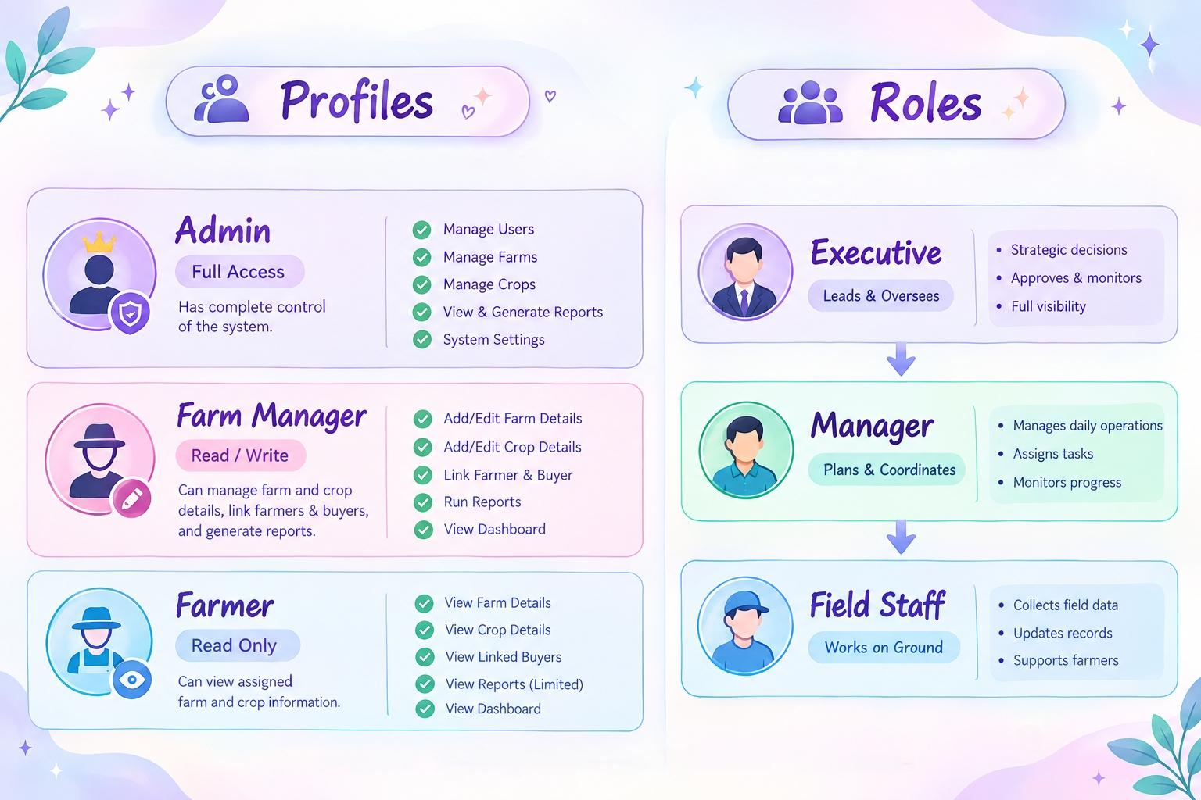

PHASE 4: PROJECT PLANNING

Task Allocation Table :

Task ID | Component | Assigned To | Status
T-1 | Org Setup & Profiles | Nafila Farveen A | Completed
T-2 | Custom Objects & Fields Creation | Ayisha Fathima M | Completed
T-3 | Relationships & Validation Rules | Hafzana Farveen J | Completed
T-4 | Custom App & Navigation Tabs | Naseema Banu M | Completed
T-5 | Reports & Dashboards Setup | Noorul Aafrin M | Completed
T-6 | Testing & Final Documentation | All Members | Completed

PHASE 5: DEVELOPMENT SUMMARY

Steps Completed in Salesforce:
- Created Developer Org and finished basic settings.
- Created 4 Custom Objects: Farm, Crop, Farmer, and Buyer Transaction.
- Added custom fields (Date, Picklist, Lookup, Currency).
- Created a Validation Rule: Harvest Date cannot be before Planting Date.
- Built the Farm Management System Lightning App and added custom tabs.
- Built 2 custom reports and added them to a main Dashboard.

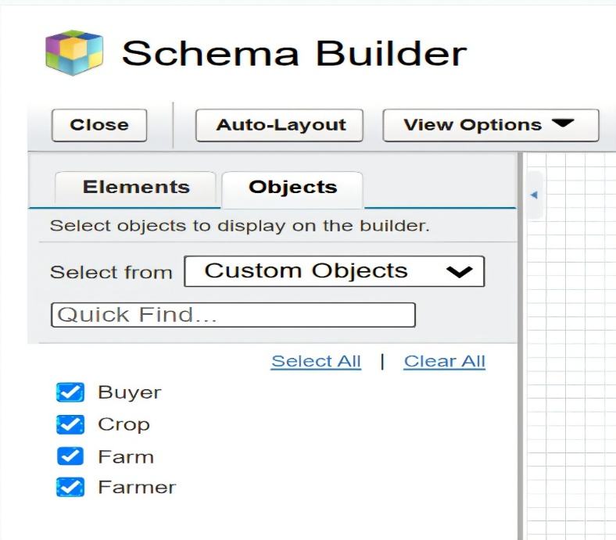
Custom Objects created :

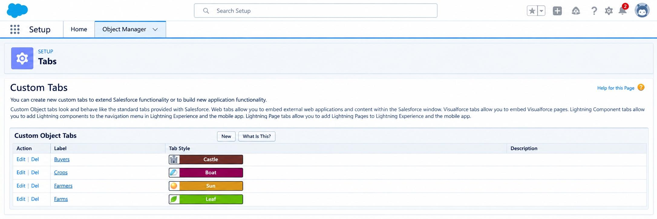
Created Custom Tabs :
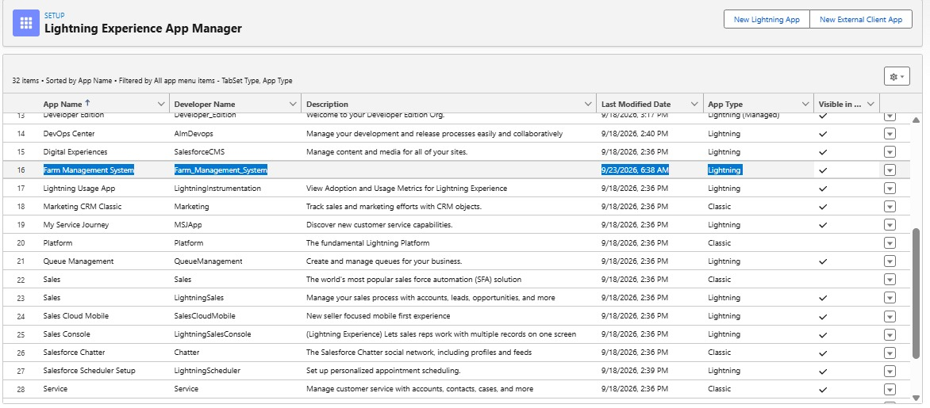
Created Farm Management System Lightning App :

Created Fields for Custom Objects mentioned above :
Farm (Farm__c) :
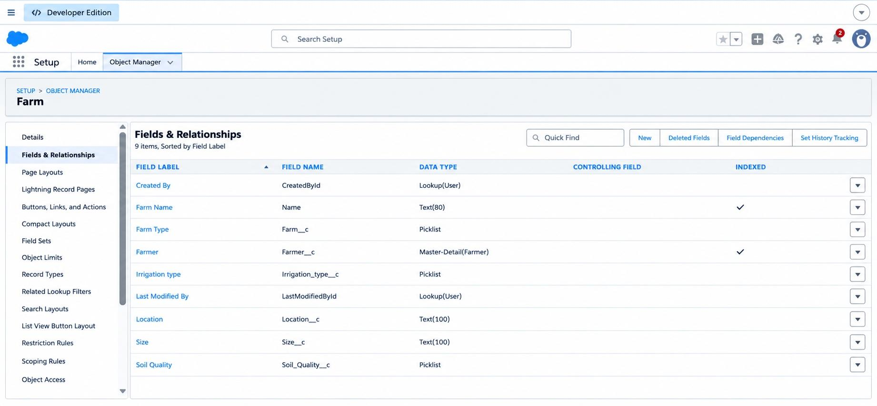

Crop (Crop__c):
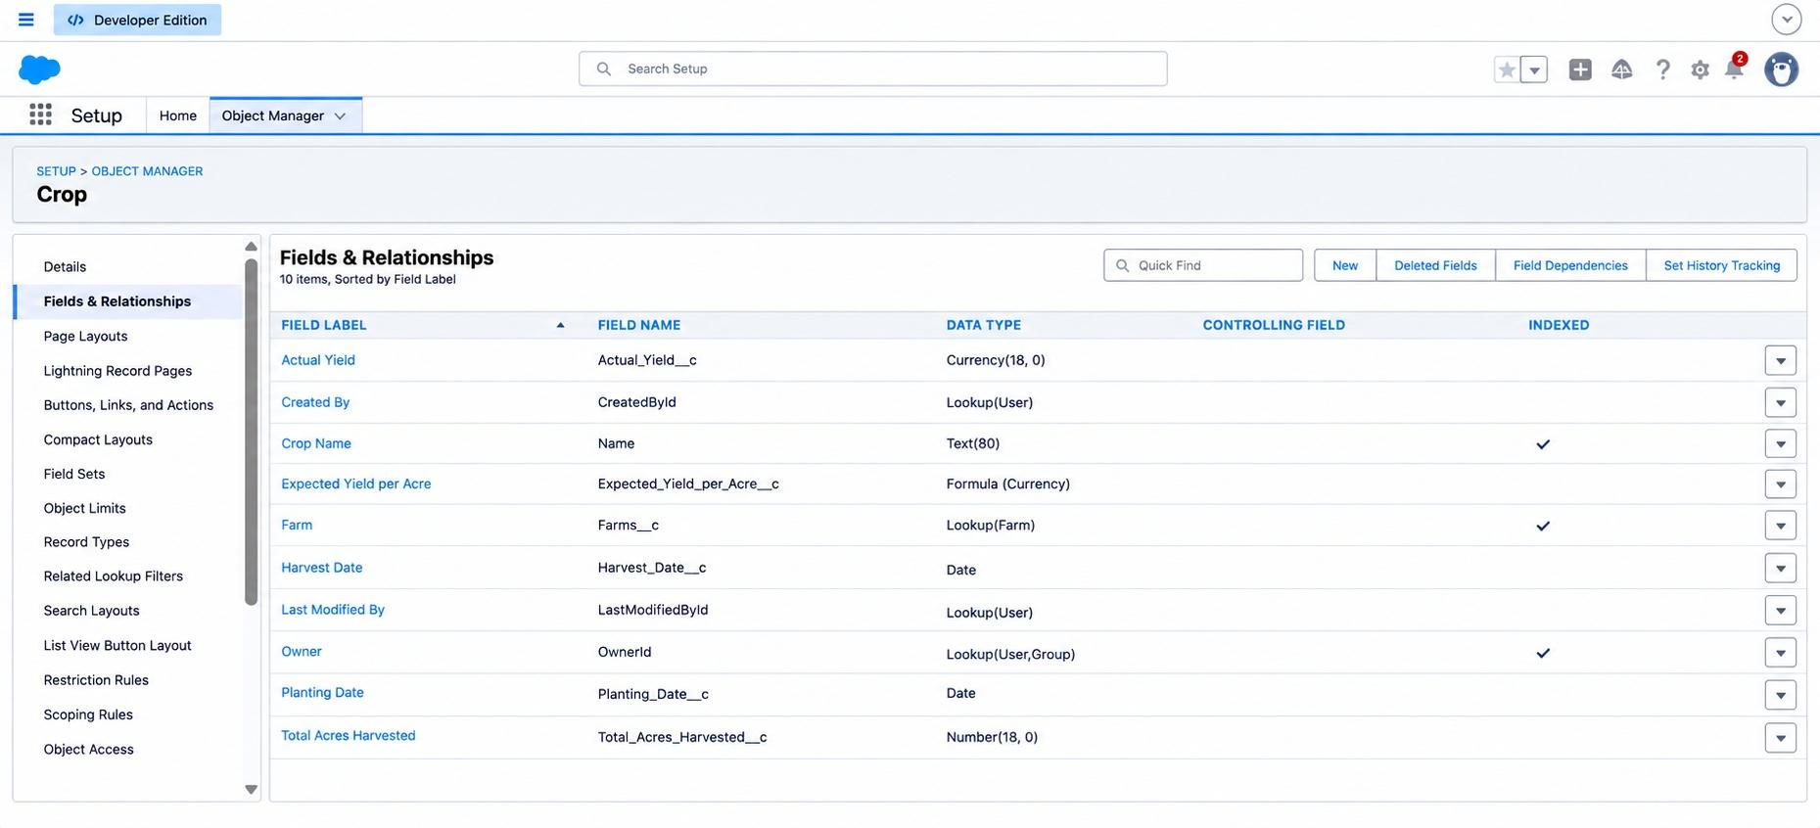

Farmer (Farmer__c):
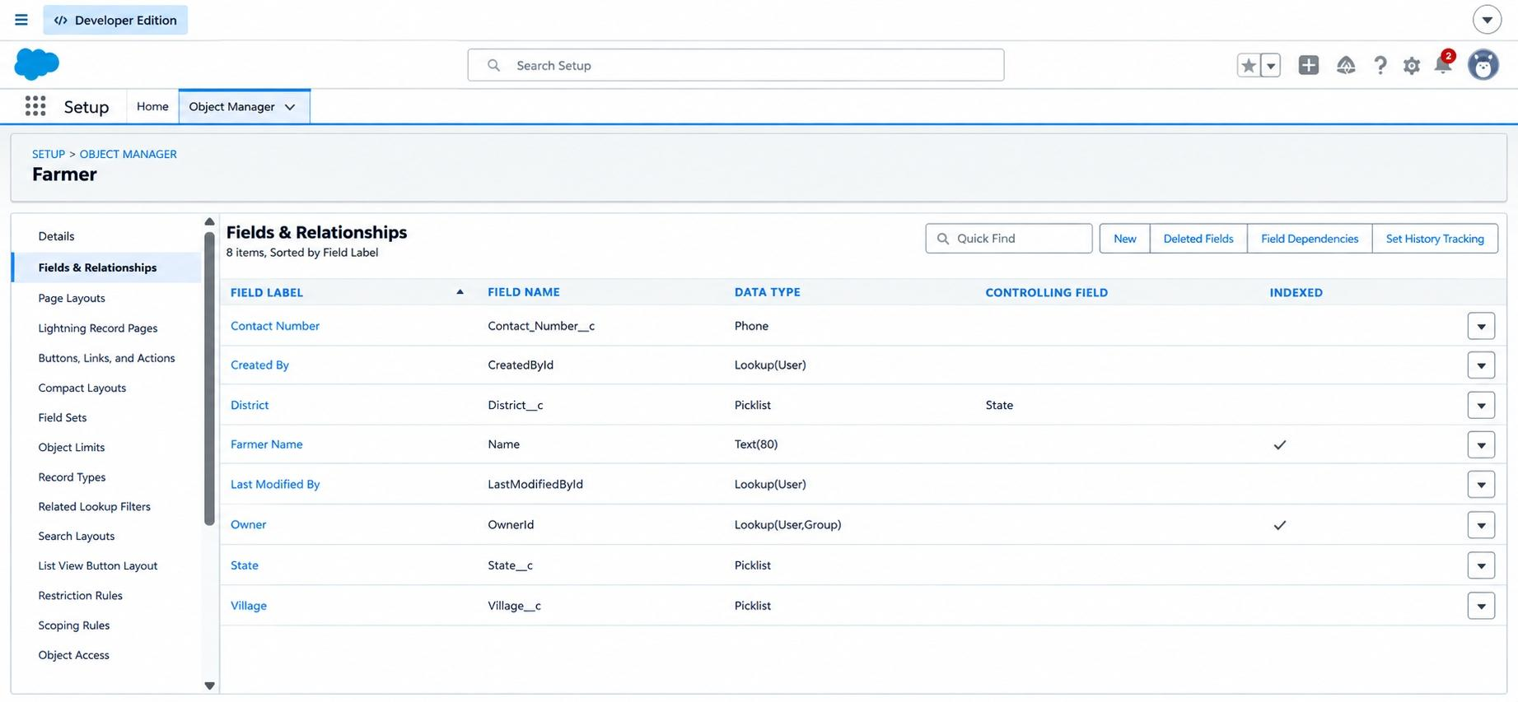

Buyer (Buyer__c):
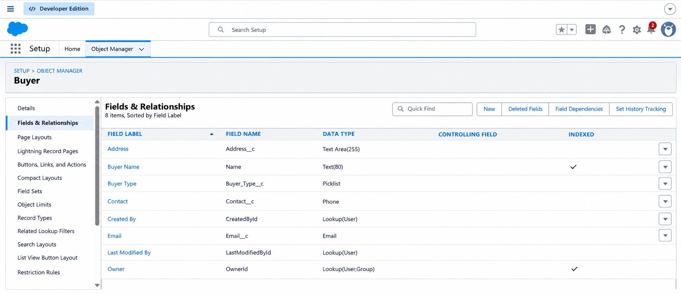

Created Profiles :
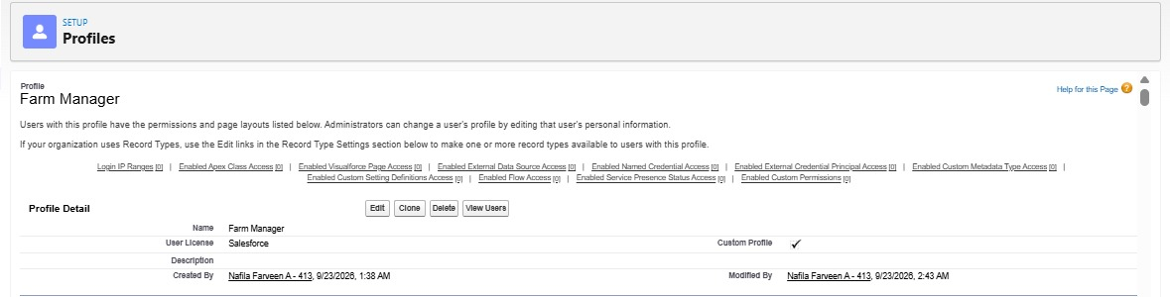
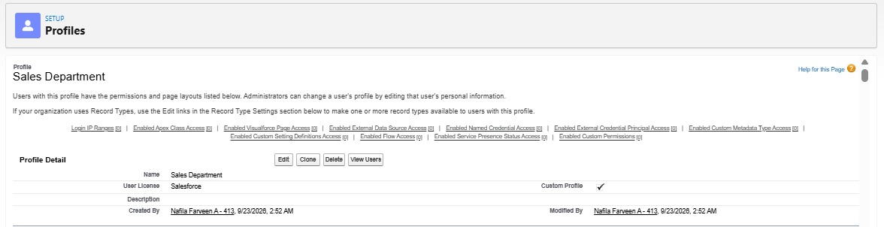
Created Role as Farmer Manager :
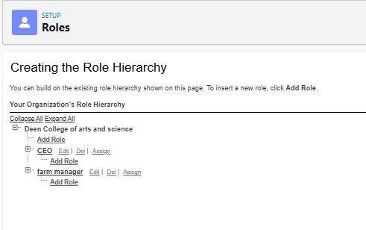

Created Users :
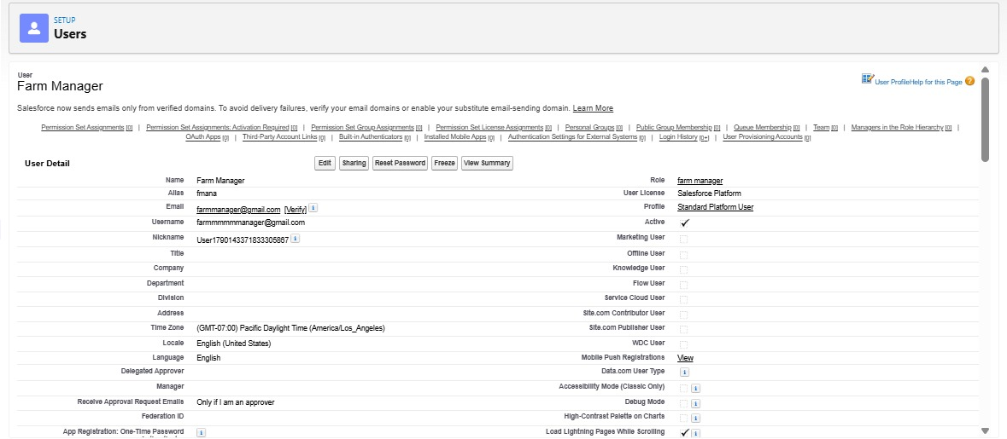

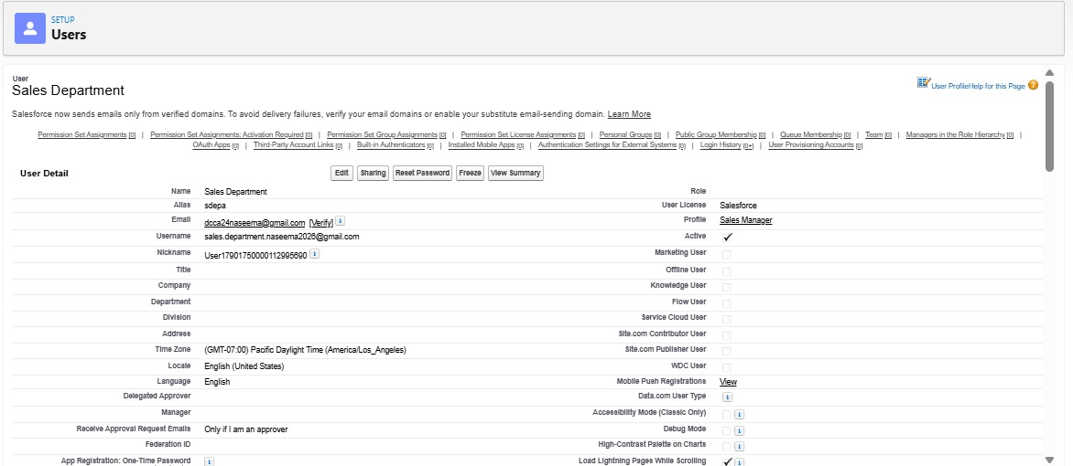

Created Sharing Rules :
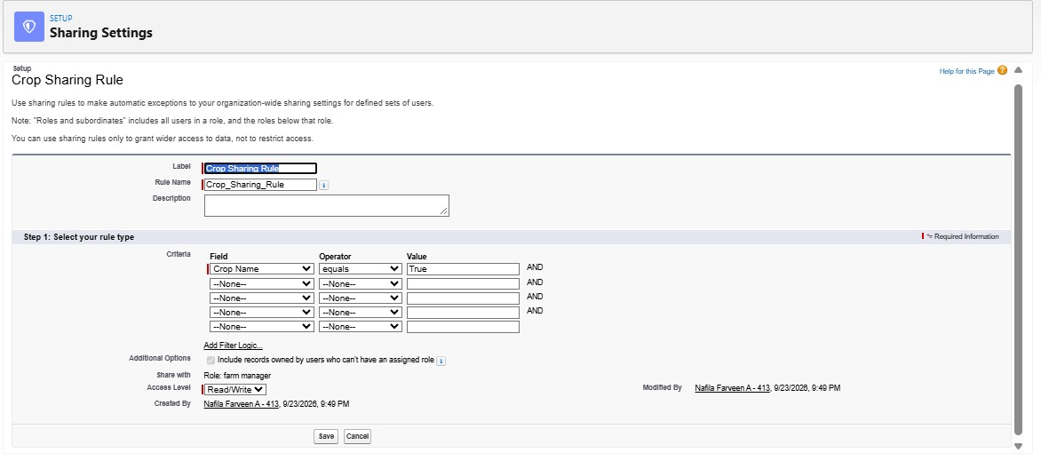

Created Farmers :
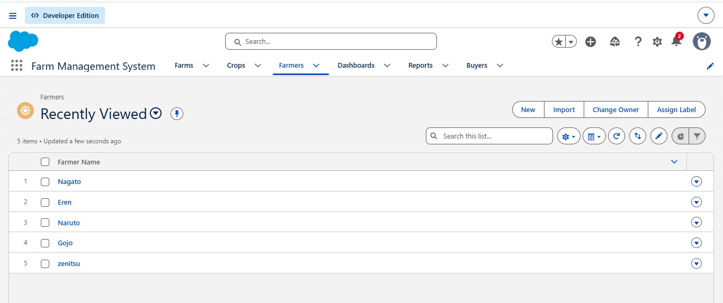

Created Reports :
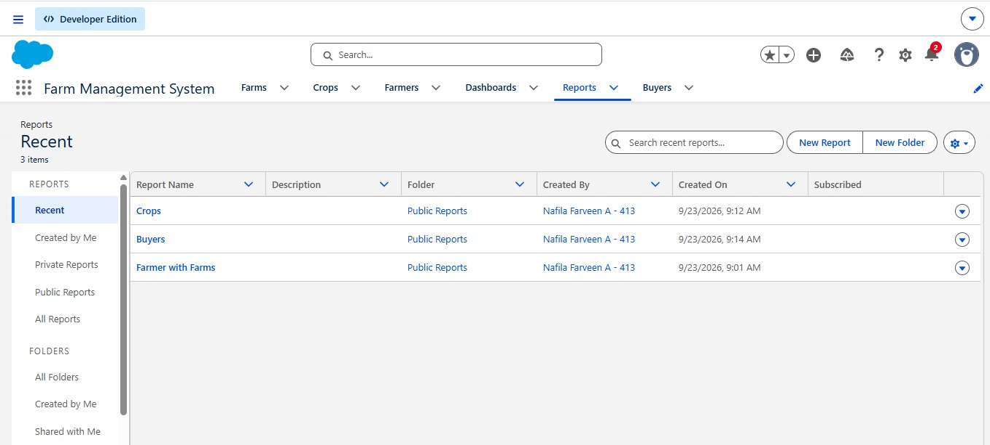
Created Dashboard :
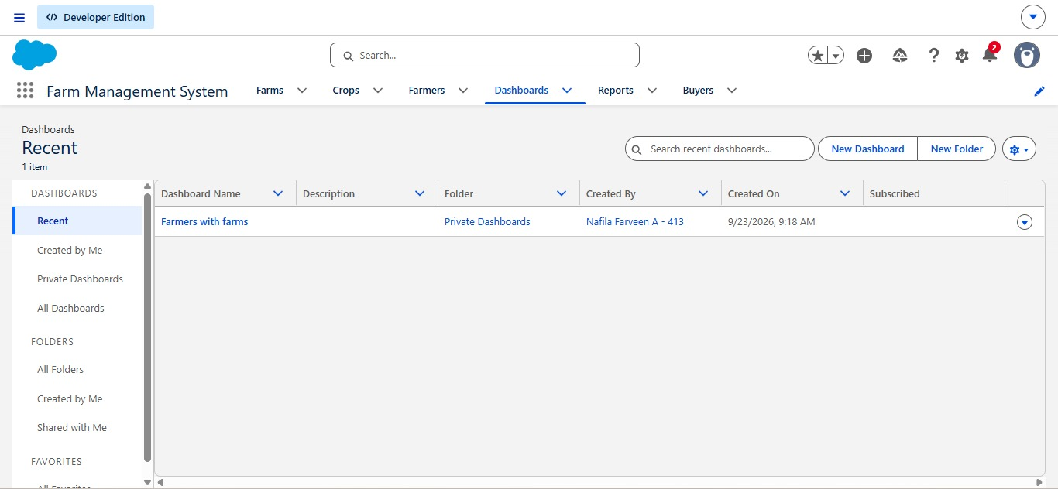

PHASE 6: TESTING REPORT

Test Execution Results :

TC ID | Test Case | Action Taken | Expected Result | Result
TC-01 | Create Farm Record | Entered valid details and clicked Save | Saved successfully | PASS
TC-02 | Date Validation Rule | Set Harvest Date before Planting Date | Blocked with Error Message | PASS
TC-03 | Profile Security Check | Logged in as Farmer profile and tried to delete Farm | Access Denied | PASS
TC-04 | Dashboard Test | Created new sales record & refreshed dashboard | Graph updated instantly | PASS

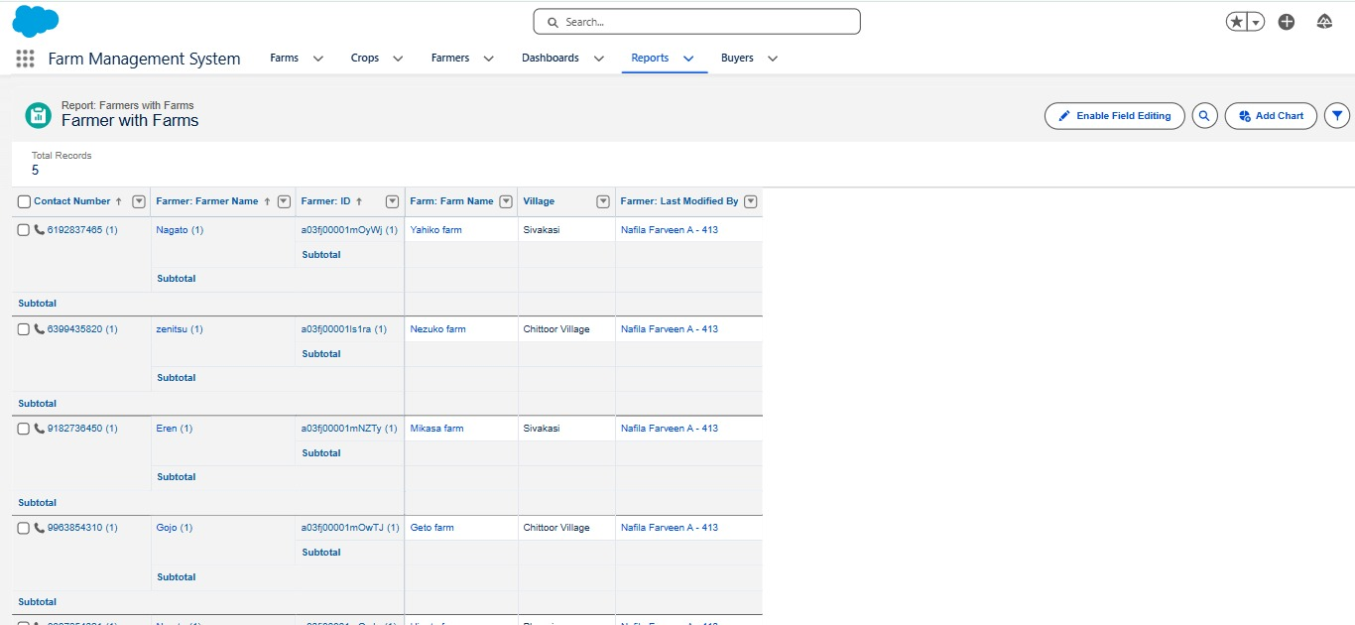
Working Reports :

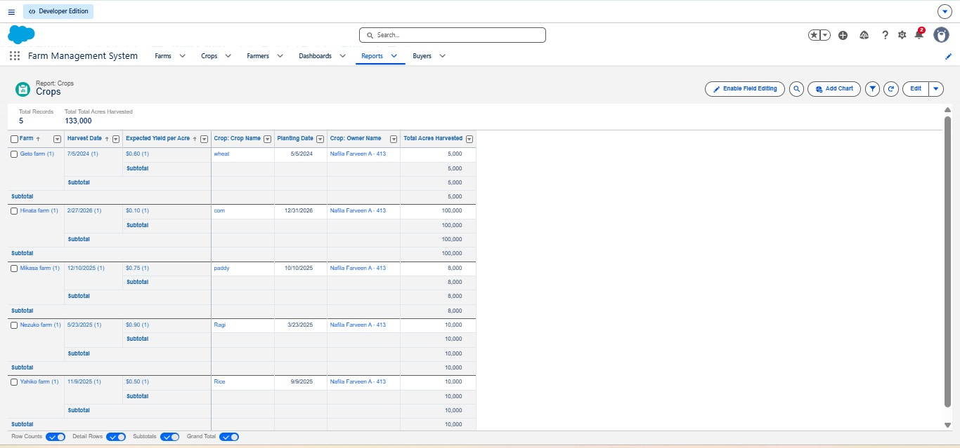
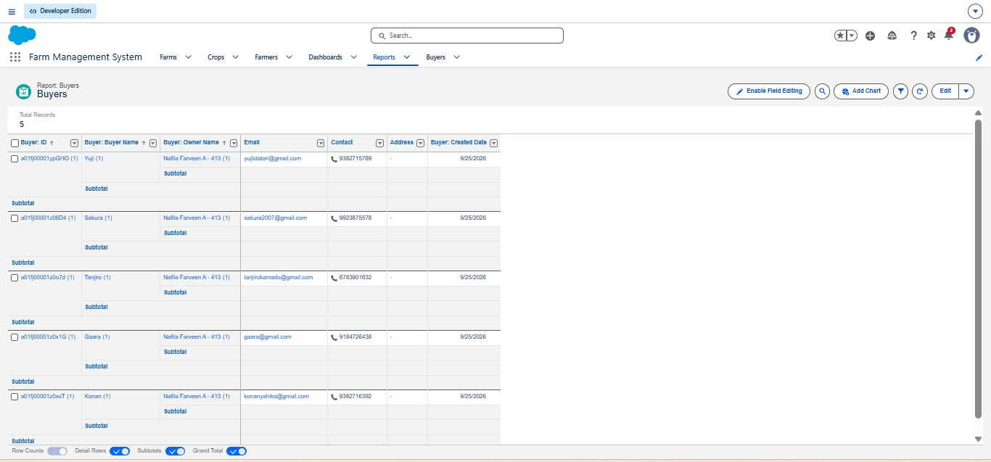
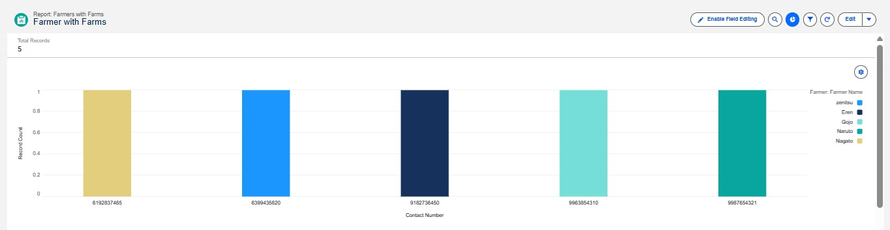

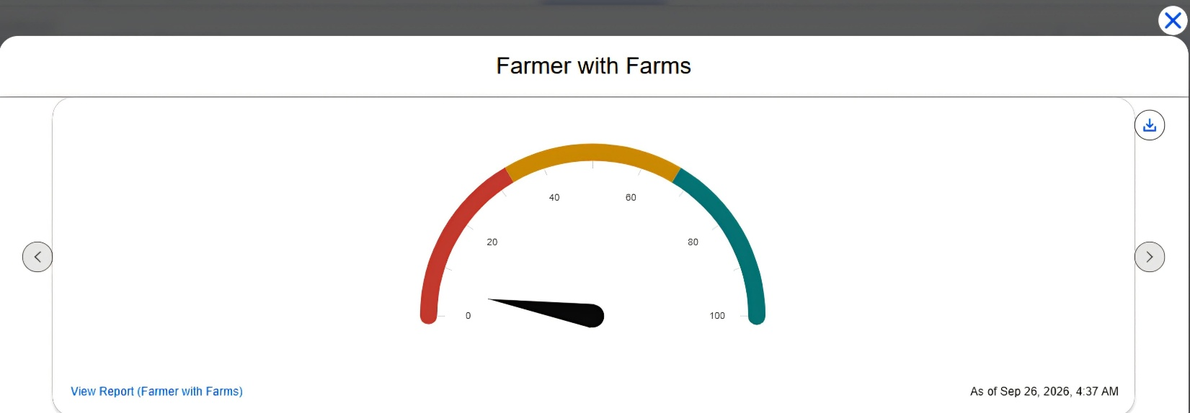
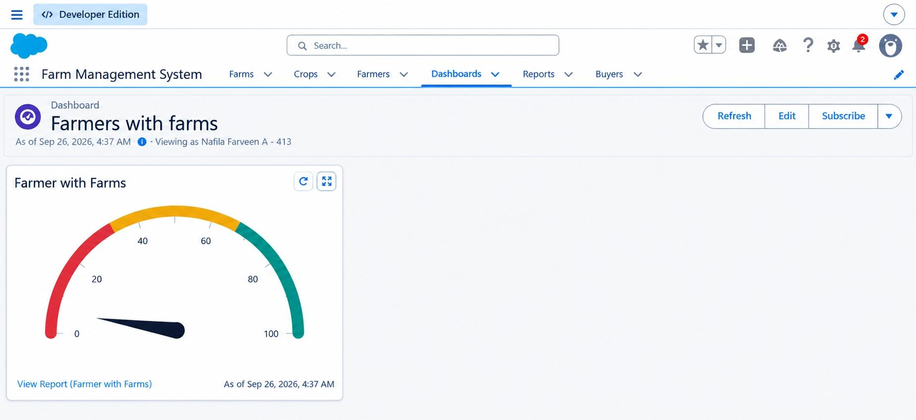
Working Dashboard :

PHASE 7: FULL PROJECT REPORT

Simple User Guide :
- Log in to Salesforce Org.
- Click App Launcher (9 dots) Open Farm Management System.
- Go to Crops tab Click New Fill details Click Save.
- Go to Buyer tab to log new sales.
- Click Dashboards tab to view total sales and crop reports.
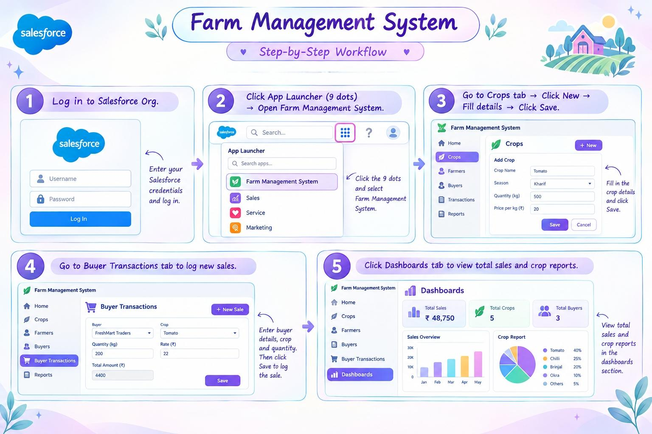

PHASE 8: DEMO LINKS

Project Output Links :
- Project Name: Farm Management System (FMS)
- GitHub Repository Link: https://github.com/nafila24DC/skillwallet-project.git
- Demo Video Link (Google Drive): https://drive.google.com/file/d/1SSUgsZlpsY-h4AirtAhDxZdgHjXmcl7a/view?usp=sharing

